Block Diagram of Arduino Based Guidance System:

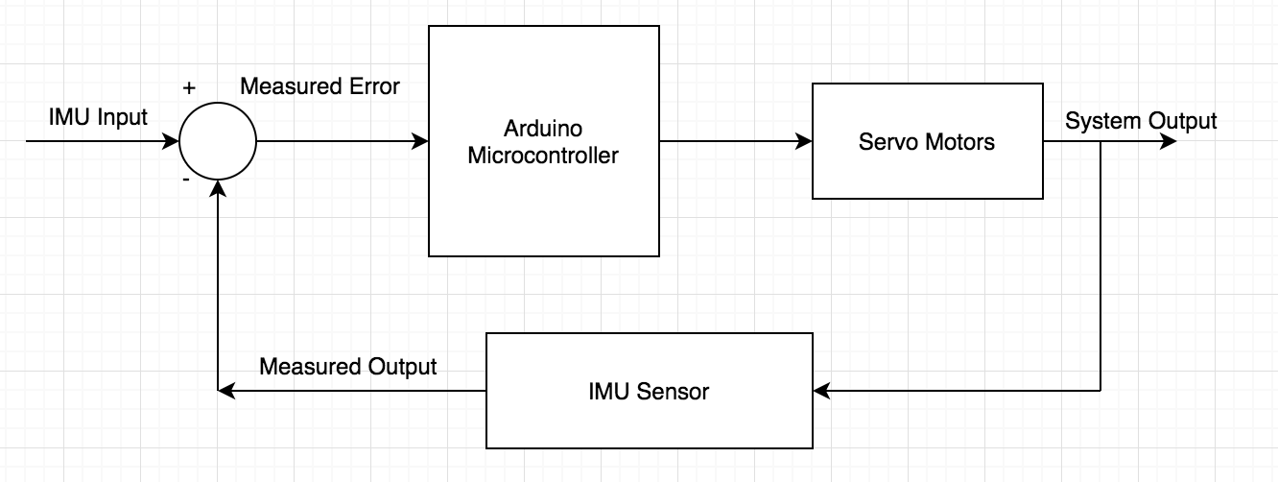

Power for Arduino Based Guidance System:

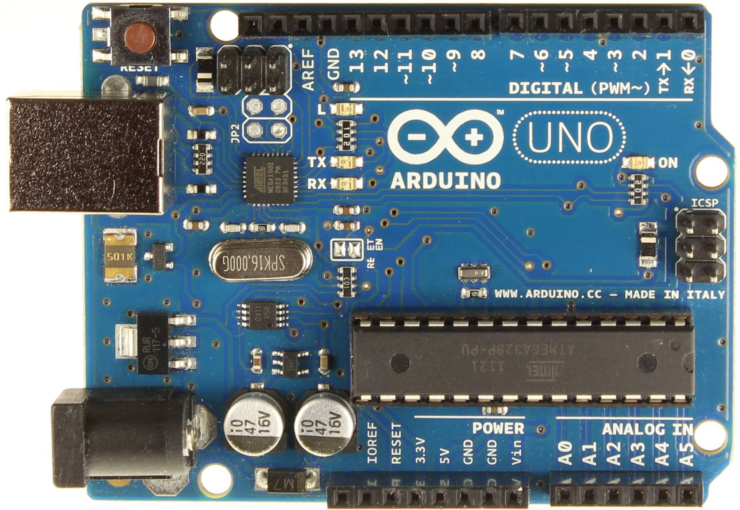

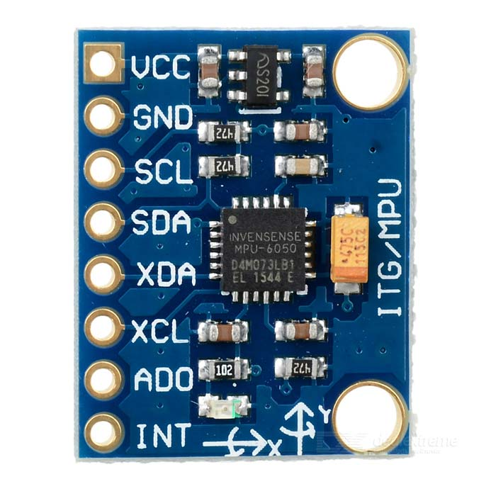

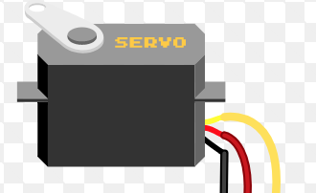

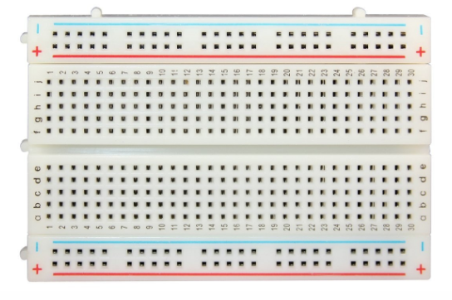

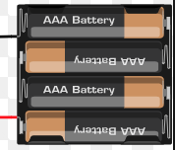



Power with Arduino Nano:

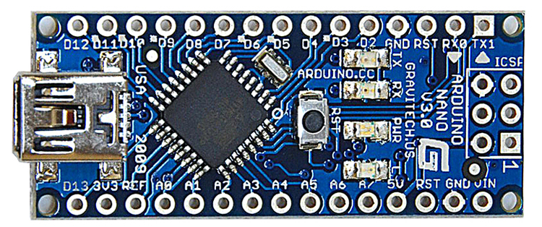

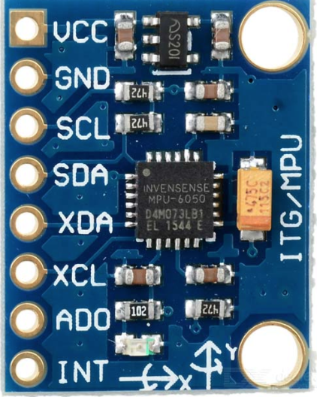

Right Servo



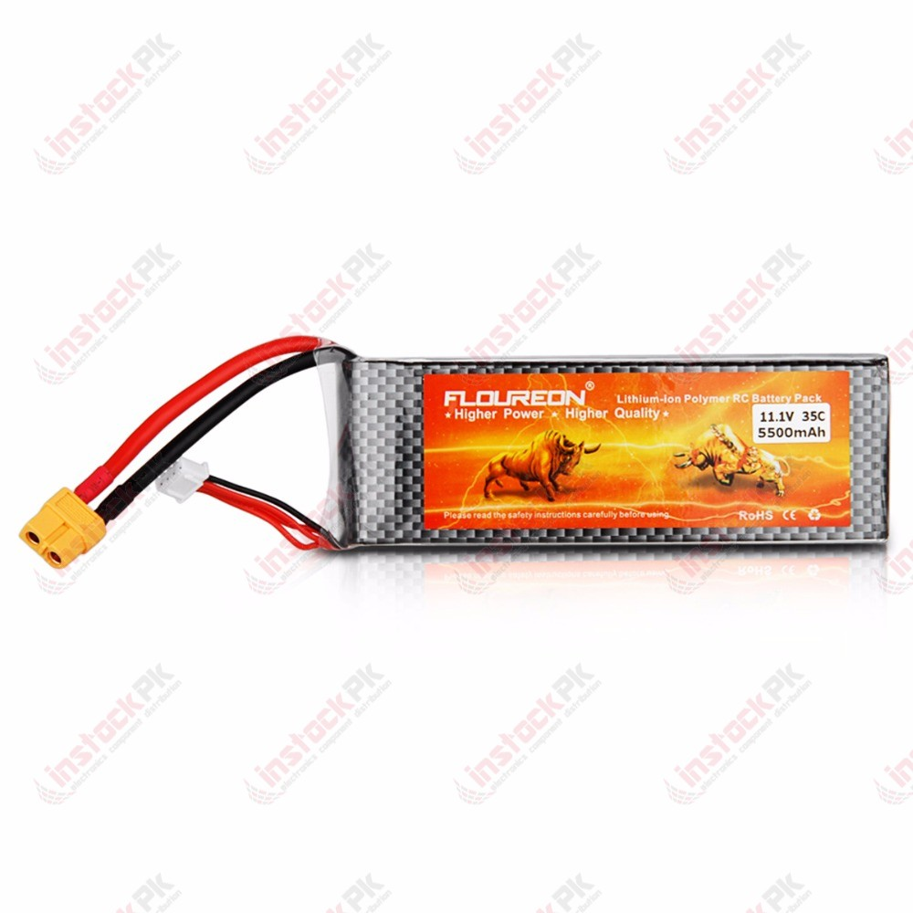

Left Servo

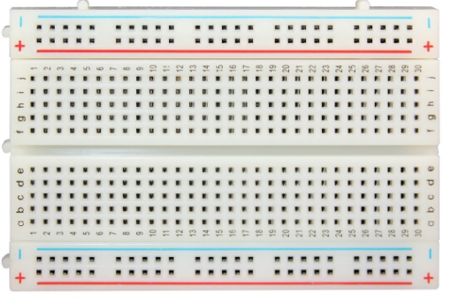



Block Diagram of the Electrical Launch System:

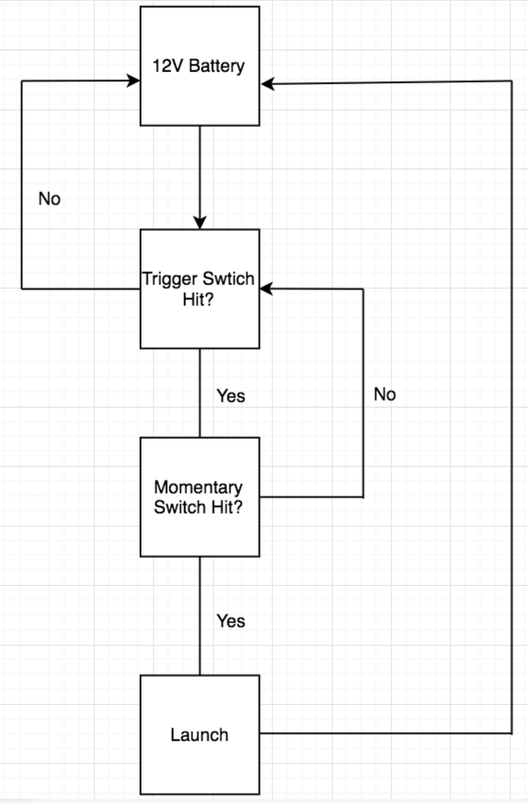

Outline of Electrical Launcher:

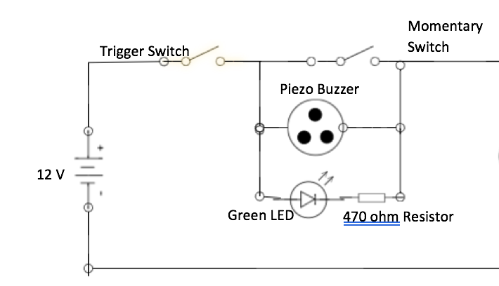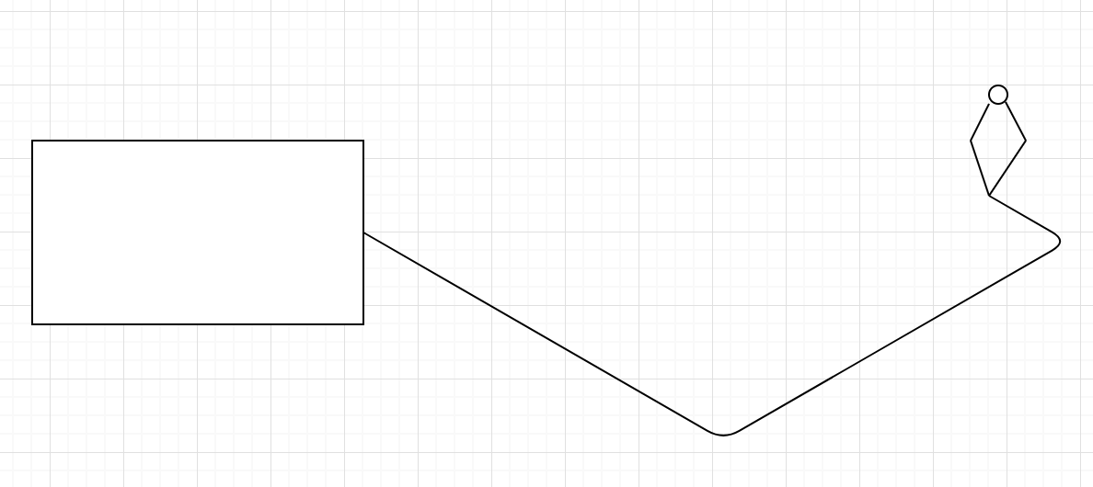

Electric Ignitor

-

+

Current 1.5 Amps

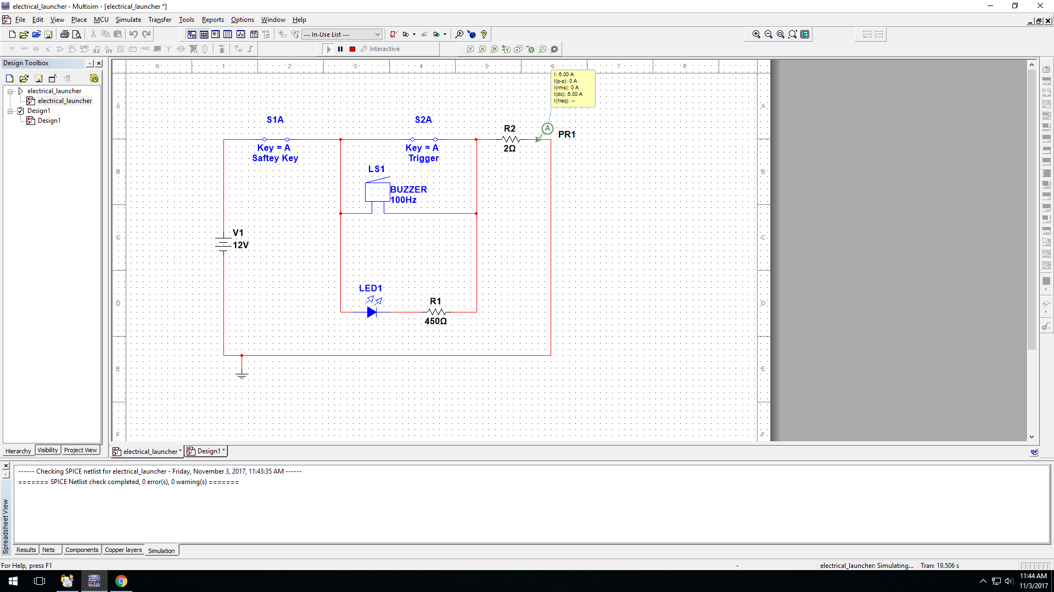

When Safety Key is Out and Trigger is Hit

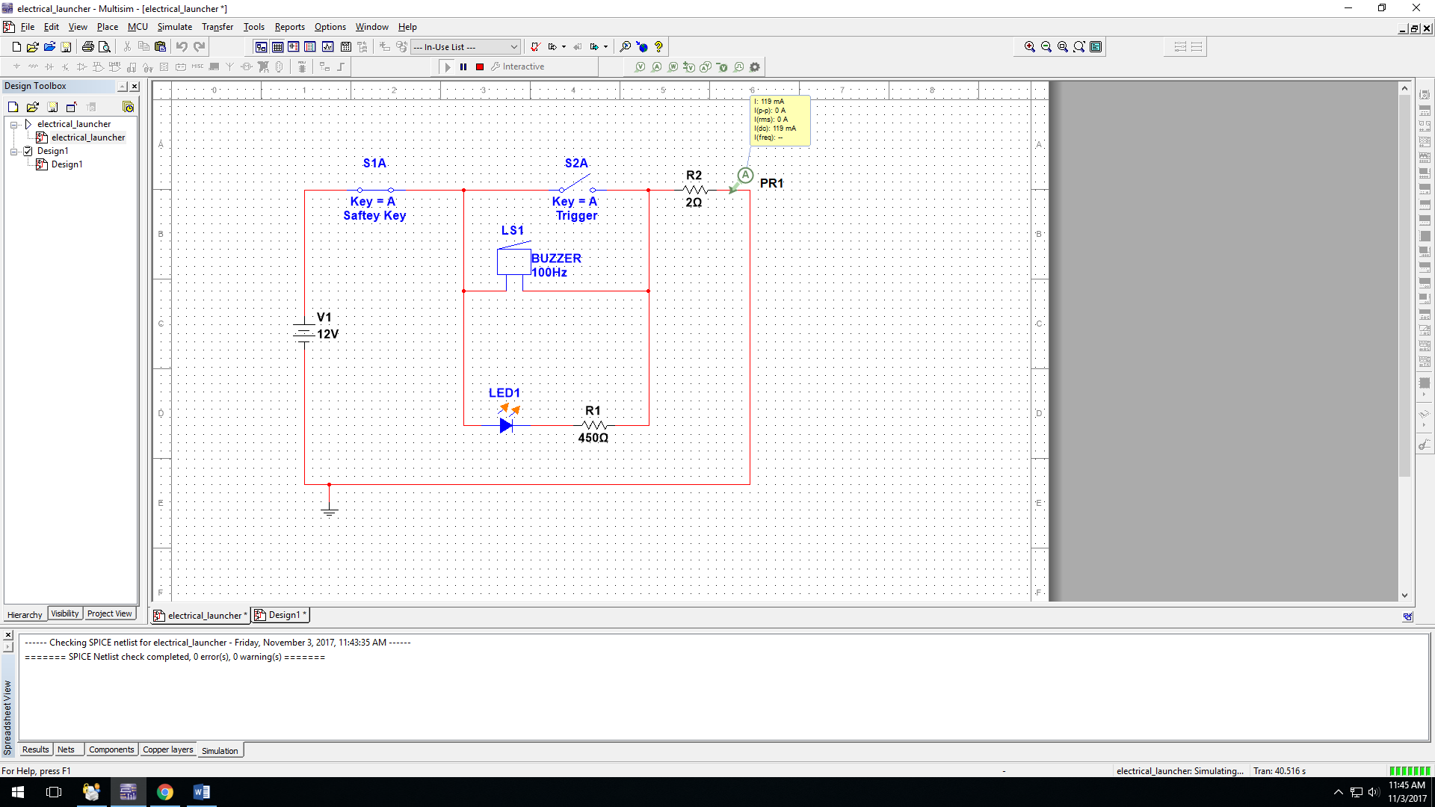

When Safety Key is Out and Trigger is not Hit

# Momentary Switch (Trigger) x 3: 2.00 each = $6.00 RadioShack SPST RED Switch

# RadioShack 76dB Piezo Buzzer = $5.19

**RadioShack 5mm Green LED x 3 = $3**

WHAT I WANT TO BUY TOMORROW:

RadioShack SPST RED Switch-

RadioShack 76dB Piezo Buzzer x 2-

RadioShack 5mm Green LED x 3-

16 Gauge Copper wire-

WHAT I HAVE:

470 ohm resistor

2 ohm resistor

Gator Clips

Soder Iron

Parachute Deployment:

The BMP280 will sense when the air pressure increases and the rocket isn’t moving up any more. Then the BMP280 will tell the Arduino when it is done moving and the Arduino will tell the servo to flip up releasing the parachute.